DR. AMBEDKAR INSTITUTE OF TECHNOLOGY
FOR HANDICAPPEDS KANPUR ( U.P )



BUS RESERVATION SYSTEM
MINI PROJECT

SUBMITTED TO: SUBMITTED BY:
DR. ABHISHEK PRABHAKAR SIR SARVESH GUPTA (ROLL NO.51)
HEAD OF DEPARTMENT VARUN DEV (ROLL NO. 61)
INFORMATION TECHNOLOGY

CERTIFICATE

This is to certify that the project work entitled “Bus Reservation System in C” is bonafide work carried out by SARVESH GUPTA and VARUN DEV, submitted in Second Year of the degree B.Tech. in Information Technology during the year 2022-23 is an authentic work under my supervision and guidance.

DR. ABHISHEK PRABHAKAR
HEAD OF DEPARTMENT
INFORMATION TECHNOLOGY

DECLARATION
We here by declare that the project submitted by us is our own work and that to the best of our knowledge. It contains previously published or written by another person, nor material which to a substantial extent has been expected for the award of our other degree or diploma of the university or other institute of higher learning except where due acknowledgement has been made in the text.

Name – Sarvesh Gupta
Roll no.- 2101660130051
Signature –

Name – Varun Dev
Roll no. – 2101660130061
Signature –

ACKNOWLEDGEMENT

We would like to express our special thanks and gratitude to our HOD sir (Dr. Abhishek Prabhakar) who gave us the opportunity and fruitful guidance to do this mini project on ‘Bus Reservation System’.

A project is a bridge between theoretical and practical learning and with this thinking we worked on the project and made it successful due to timely support and efforts of all who helped us.

INDEX

- ABOUT
- INTRODUCTION
- FEATURES
- HARDWARE/SOFTWARE REQUIREMENT
- TECHNOLOGY DESCRIPTION
- SOURCE CODE
- OUTPUT(RESULT)
- CONCLUSION AND FUTURE IMPROVEMENTS
- REFERENCES

ABOUT

The C programming language was used to create this.
- It's simple to use and comprehend.
- Bus information, such as bus number and driver's name, may be uploaded by users.
- Furthermore, since the reservation is made in the passenger's name, it is pretty straightforward.
- In addition, the system displays all information about the buses and their corresponding seats.
- This system also displays the buses that may be reserved.

INTRODUCTION

We have created a project in C language that is Bus Reservation System .
The primary goal of this project is to create an application that allows users to make bus reservations. Instead of using file management to store bus information, this system uses a different method.
This desktop program utilizes a command database as the system's backend.

HARDWARE/SOFTWARE REQUIREMENT

MINIMUM HARDWATRE REQUIREMENTS
PROCESSOR: DUAL CORE OR ABOVE
RAM: 8GB OR ABOVE
HARD DISK: 256GB OR ABOVE
PRINTER: LINE_PRINTER (DOT MATRIX/INKJET)
KEYBOARD: NORMAL OR ABOVE

APPLICATION SOFTWARE
DEV C++
OPERATING SYSTEM(THAT WE USED): WINDOWS 11
SYSTEM TYPE: A 32BIT OR 64BIT Operating system
LANGUAGE: C

FEATURES

1. Proper login system
2. Booking system
3. Cancelling booking
4. Bus Status

TECHNOLOGY DESCRIPTION

The programming language is a procedural and general-purpose language that provides low-level access to system memory. A program written in C must be run through a C compiler to convert it into an executable that a computer can run. Many versions of Unix -based operating systems (OSes) are written in C and it has been standardized as part of the Portable Operating System Interface (POSIX).
Today, the C programming lang The Cage runs on many different hardware platforms and OSes such as Microsoft and LINUX.
FACTS ABOUT C:
- ‘C’ was developed by Dennis Ritchie in 1972
- It is one of the most popular programming language in the world
- If we know C, we will have no problem learning other popular programming languages such as Java, Python, C++, C#, etc, as the syntax is similar
- C is very fast, compared to other programming languages, like Java and Python
- C is very versatile, it can be used in both applications and technologies
Features of ‘C’ language
- Simple
- Machine Independent or Portable
- Mid-level programming language
- structured programming language
- Rich Library
- Memory Management
- Fast Speed
- Pointers
- Recursion
- Extensible

SOURCE CODE

//BROUGHT TO YOU BY code-projects.org//
#include <stdio.h>
#include <stdlib.h>
#include <string.h>
char ch[10][130]={"Cardiff Express","Belfast Express","Derby Express","Chester Express","Newport Express","Truro Express"};
char name[32][100]={'\0'};
char number[32][2]={'\0'};
int num1[32]={0};
int trno;
void bus();//for list of bus
void name_number(int booking,char numstr[100]);
void booking();//for booking the tickets
int read_number(int trno);//for reading the number from the file
void read_name(int trno);//for reading the name from the file
void status();//for printing the status by user input
void status_1(int trno);//for printing the status while booking ticket
void cancle();
int main()
{
login();
int num,i;
do{
system("cls");
printf("\n\n\n");
printf("====================================== WELCOME TO BUS RESERVATION SYSTEM ======================================\n\n\n");
printf("\t\t\t\t\t[1]=> View Bus List\n");
printf("\n");
printf("\t\t\t\t\t[2]=> Book Tickets\n");
printf("\n");
printf("\t\t\t\t\t[3]=> Cancle Booking\n");
printf("\n");
printf("\t\t\t\t\t[4]=> Bus Status Board\n");
printf("\n");
printf("\t\t\t\t\t[5]=> Exit\n\n");
printf("===============================================================================================================\n\n");
printf("\t\t\tEnter Your Choice:: ");
scanf("%d",&num);
switch(num)
{
case 1:
bus();//for list of bus
break;
case 2:
booking();//for booking the tickets
break;
case 3:
cancle();
break;
case 4:
status();
break;
}
getch();
}while(num != 5);
system("CLS");
printf("\t----------------------------------------------------------------------------------------------------------\n");
printf("\t\t\t\t\tThank You For Using This System\t\t\t\t\t\t\n");
printf("\t----------------------------------------------------------------------------------------------------------\n");
printf("\t\t\t Brought To You By code-projects.org");
getch();
return 0;
}
void bus()
{
system("cls");
printf("\n\n\n");
printf("=========================================== BUS RESERVATION SYSTEM ============================================\n\n\n");
printf("\t\t\t\t\t[1] => %s\n",ch[0]);
printf("\n");
printf("\t\t\t\t\t[2] => %s\n",ch[1]);
printf("\n");
printf("\t\t\t\t\t[3] => %s\n",ch[2]);
printf("\n");
printf("\t\t\t\t\t[4] => %s\n",ch[3]);
printf("\n");
printf("\t\t\t\t\t[5] => %s\n",ch[4]);
}
void booking()
{
int i=0;
char numstr[100];
system("cls");
printf("=========================================== BUS RESERVATION SYSTEM ============================================\n\n\n");//for entering train number
bus();//for seeing train least
printf("Enter the Bus number:--->");
scanf("%d",&trno);
system("cls");
printf("=========================================== BUS RESERVATION SYSTEM ============================================\n\n\n");//for selecting coach
printf("Your Bus Number is %d ********** %s",trno,ch[trno-1]);
status_1(trno);
FILE *f1, *fopen();//for reading the seats from the user.
char str1[80]="32",str2[4],str3[4];
int seat1,seat2,booking=0;
if(trno == 1)
{
f1 = fopen("tr1.txt","r+");
fgets(str1,80,f1);
fclose(f1);
}else if(trno == 2)
{
f1 = fopen("tr2.txt","r+");
fgets(str1,80,f1);
fclose(f1);
}else if(trno == 3)
{
f1 = fopen("tr3.txt","r+");
fgets(str1,80,f1);
fclose(f1);
}
else if(trno == 4)
{
f1 = fopen("tr4.txt","r+");
fgets(str1,80,f1);
fclose(f1);
}
else if(trno == 5)
{
f1 = fopen("tr5.txt","r+");
fgets(str1,80,f1);
fclose(f1);
}
seat1=atoi(str1);//covert the string into number
if(seat1 <= 0)
{
printf("There is no blank seat in this bus ");
}else
{
printf("\n\n\n\t\t\t\tAvailable Seats:------>%d\n",seat1);
printf("\n\t\t\t\tNumber of Tickets:----->");
scanf("%d",&booking);
printf("\n");
seat1=seat1-booking;
itoa(trno,numstr,10);
name_number(booking,numstr);
printf("\n\t\t\t\tThe Total booking amount is %d",200*booking);
itoa(seat1, str1, 10);
//for reading the seats from the user.
if(trno == 1)
{
f1 = fopen("tr1.txt","w");
fputs(str1,f1);
fclose(f1);
}
else if(trno == 2)
{
f1 = fopen("tr2.txt","w");
fputs(str1,f1);
fclose(f1);
}
else if(trno == 3)
{
f1 = fopen("tr3.txt","w");
fputs(str1,f1);
fclose(f1);
}
else if(trno == 4)
{
f1 = fopen("tr4.txt","w");
fputs(str1,f1);
fclose(f1);
}
else if(trno == 5)
{
f1 = fopen("tr5.txt","w");
fputs(str1,f1);
fclose(f1);
}
}
}
void name_number(int booking,char numstr[100])
{
char tempstr[100],tempstr1[12]="status",tempstr2[12]="number";
int number;
FILE *a,*b;
int i=0;
strcat(numstr,".txt");
strcat(tempstr1,numstr);
strcat(tempstr2,numstr);
a = fopen(tempstr1,"a");//for open the file to write the name in the file
b = fopen(tempstr2,"a");//for open the file for writing the number in the file
for(i=0; i<booking; i++)//for entering the person name and seat number in the file
{
printf("============================Enter the details for ticket no %d============================\n\n\n",i+1);
printf("\t\t\t\tEnter the seat number:--->");
scanf("%d",&number);
printf("\t\t\t\tEnter the name of person:--->");
scanf("%s",name[number-1]);
printf("\n======================================================================================================\n\n");
printf("\n");
itoa(number, tempstr, 10);
fprintf(a,"%s ",name[number-1]);
fprintf(b,"%s ",tempstr);
}
fclose(a);
fclose(b);
}
int read_number(int trno)//for putting the numeric value in the array
{
char tempstr[100],tempstr2[12]="number";
FILE *a,*b;
char numstr[100];
int i=0,j=0,k;
itoa(trno,numstr,10);
strcat(numstr,".txt");
strcat(tempstr2,numstr);
a = fopen(tempstr2,"a+");//for open the file to write the name in the file
while(!feof(a))
{
number[i][j] = fgetc(a);
if(number[i][j] == ' ')
{
j=0;
i++;
}
else
{
j++;
}
}
k=i;
for(i=0; i<k; i++)
{
num1[i] = atoi(number[i]);
}
fclose(a);
return k;
}
void read_name(int trno)//for putting the numeric value in the array
{
char tempstr1[12]="status";
FILE *b;
char numstr[100];
int i=0,j=0,k=0;
itoa(trno,numstr,10);
strcat(numstr,".txt");
strcat(tempstr1,numstr);
b = fopen(tempstr1,"a+");//for open the file to write the name in the file
while(!feof(b))
{
name[i][j] = fgetc(b);
if(name[i][j] == ' ')
{
j=0;
i++;
}
else
{
j++;
}
}
name[i][j]='\0';
k=i;
fclose(b);
}
void status()
{
system("cls");
printf("=========================================== BUS RESERVATION SYSTEM ============================================\n\n\n");
int i,trno,index=0,j;
printf("Enter the number of bus:---->");
scanf("%d",&trno);
j=read_number(trno);
read_name(trno);
printf("____________________________________________________________________________________________________________________\n");
printf(" Bus.no-->%d---->%s \n",trno,ch[trno-1]);
printf("____________________________________________________________________________________________________________________\n");
char tempname[33][10]={"Empty ","Empty ","Empty ","Empty ","Empty ","Empty ","Empty ","Empty ","Empty ","Empty ","Empty ","Empty ","Empty ","Empty ","Empty ","Empty ","Empty ","Empty ","Empty ","Empty ","Empty ","Empty ","Empty ","Empty ","Empty ","Empty ","Empty ","Empty ","Empty ","Empty ","Empty ","Empty ","Empty "};
for(i=0; i<j; i++)
{
strcpy(tempname[num1[i]],name[i]);
}
for(i=0; i<8; i++)
{
printf("\t\t\t\t");
for(j=0; j<4; j++)
{
printf("%d.%s\t",index+1,tempname[index+1]);
index++;
}
printf("\n");
}
}
void status_1(int trno)
{
printf("Your Bus Number is %d ********** %s",trno,ch[trno-1]);
system("cls");
printf("=========================================== BUS RESERVATION SYSTEM ============================================\n\n\n");
int i,index=0,j;
j=read_number(trno);
read_name(trno);
char tempname[33][10]={"Empty ","Empty ","Empty ","Empty ","Empty ","Empty ","Empty ","Empty ","Empty ","Empty ","Empty ","Empty ","Empty ","Empty ","Empty ","Empty ","Empty ","Empty ","Empty ","Empty ","Empty ","Empty ","Empty ","Empty ","Empty ","Empty ","Empty ","Empty ","Empty ","Empty ","Empty ","Empty ","Empty "};
for(i=0; i<j; i++)
{
strcpy(tempname[num1[i]],name[i]);
}
for(i=0; i<8; i++)
{
printf("\t\t\t\t");
for(j=0; j<4; j++)
{
printf("%d.%s\t",index+1,tempname[index+1]);
index++;
}
printf("\n");
}
}
void cancle()
{
int seat_no,i,j;
char numstr[100],tempstr2[15]="number",tempstr1[15]="status";
printf("Enter the bus number:---->");
scanf("%d",&trno);
itoa(trno,numstr,10);
strcat(numstr,".txt");
strcat(tempstr1,numstr);
strcat(tempstr2,numstr);
read_number(trno);
read_name(trno);
status_1(trno);
printf("Enter the seat number:--->");
scanf("%d",&seat_no);
FILE *a,*b;
a = fopen(tempstr1,"w+");
b = fopen(tempstr2,"w+");
for(i=0; i<32; i++)
{
if(num1[i] == seat_no)
{
for(j=0; j<32; j++)
{
if(num1[j] != seat_no && num1[j] != 0)
{
fprintf(b,"%d ",num1[j]);
fprintf(a,"%s",name[j]);
}
else if(num1[j] == seat_no && num1[j] != 0)
{
strcpy(name[j],"Empty ");
}
}
}
}
fclose(a);
fclose(b);
printf("\n\n");
printf("======================================================================================================\n");
printf("\t\t\t\tYour 200 rupees has been Returned\t\t\t\n");
printf("======================================================================================================\n");
}
void login()
{
int a=0,i=0;
char uname[10],c=' ';
char pword[10],code[10];
char user[10]="user";
char pass[10]="pass";
do
{
system("cls");
printf("\n ========================= LOGIN FORM ========================= ");
printf(" \n ENTER USERNAME:-");
scanf("%s", &uname);
printf(" \n ENTER PASSWORD:-");
while(i<10)
{
pword[i]=getch();
c=pword[i];
if(c==13) break;
else printf("*");
i++;
}
pword[i]='\0';
//char code=pword;
i=0;
//scanf("%s",&pword);
if(strcmp(uname,"user")==0 && strcmp(pword,"pass")==0)
{
printf(" \n\n\n WELCOME TO OUR SYSTEM !!!! LOGIN IS SUCCESSFUL");
printf("\n\n\n\t\t\t\tPress any key to continue...");
getch();//holds the screen
break;
}
else
{
printf("\n SORRY !!!! LOGIN IS UNSUCESSFUL");
a++;
getch();//holds the screen
}
}
while(a<=2);
if (a>2)
{
printf("\nSorry you have entered the wrong username and password for four times!!!");
getch();
}
system("cls");
}

OUTPUT(RESULT)

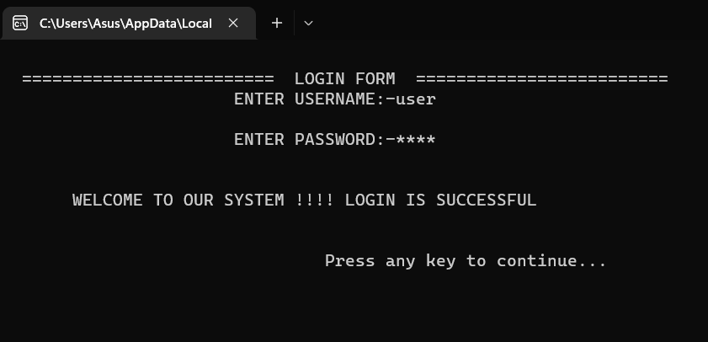

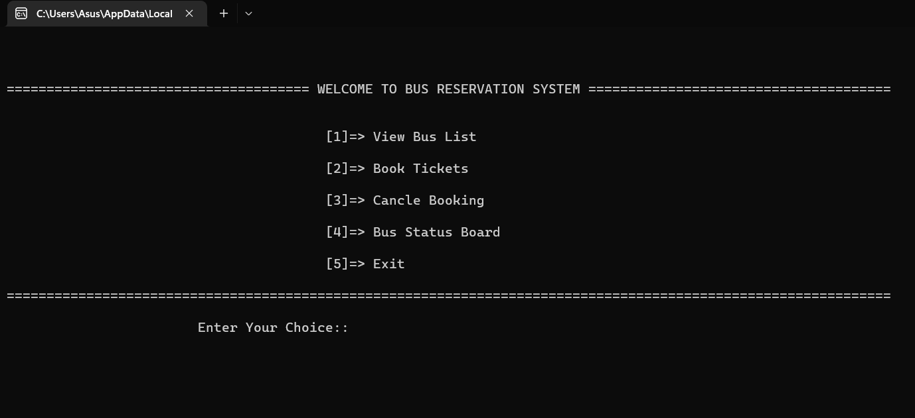
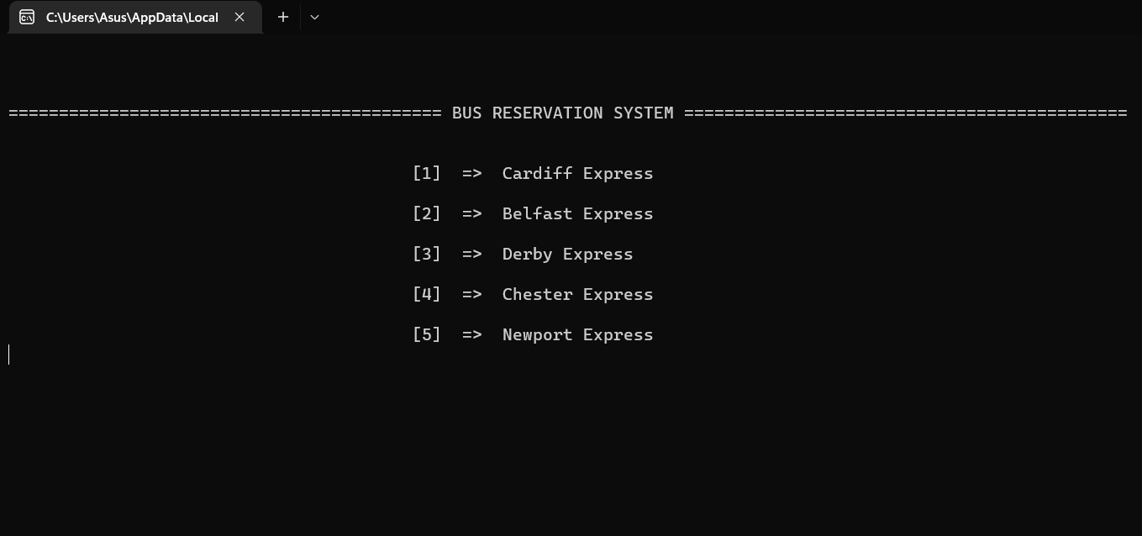
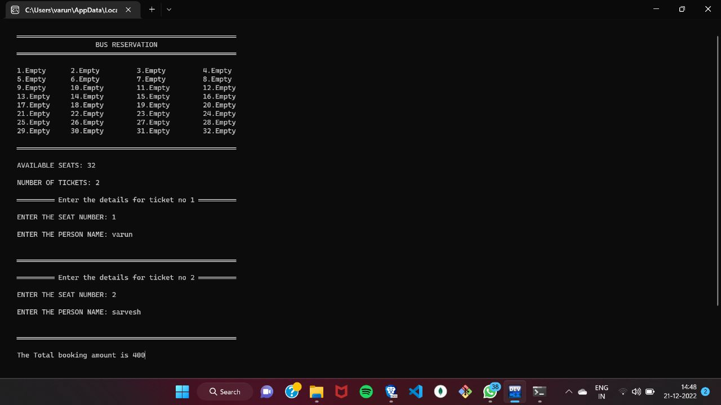

CONCLUSION

After implementing a bus reservation system using the C programming language, it can be concluded that C is a powerful and efficient language for developing such a system. The use of functions and pointers in C allows for effective organization and management of data, making it easy to handle large amounts of information such as bus routes, schedules, and passenger information. Additionally, the ability to directly manipulate memory and control the flow of execution with control structures such as if statements and for loops allows for precise control over the system's behavior. Overall, the use of C in a bus reservation system results in a reliable and efficient system that can handle a high volume of reservations and provide a smooth experience for passengers

REFERENCES

1. www.github.com
2. www.interviewbit.com
3. www.mygreatlearning.com
4. www.Itsource.com (About ‘C’ language)
5. Wikipedia the free encyclopaedia

